Practical No.3
Nasrullah /44
By default parent class constructor gets invoked
Input:
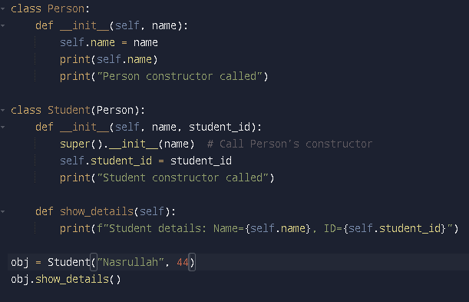

Output:
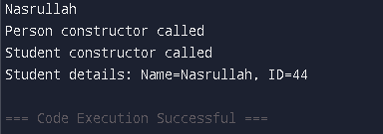
Here if child class have constructor then it get invoked rather than parent class.

Input:
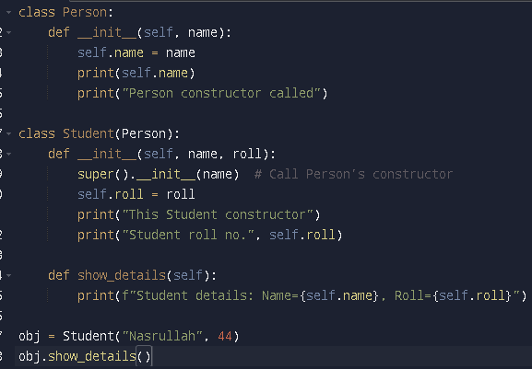

Output:
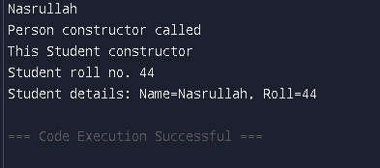
We can use super() to invoke init constructor of parent class
Input:
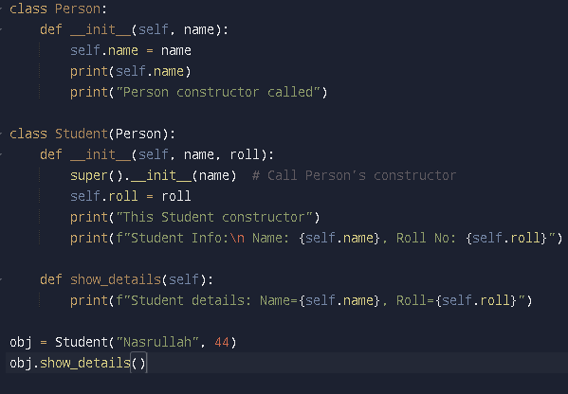

Output:
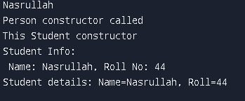
• Method Overriding
a) Overriding in constructor
Input:
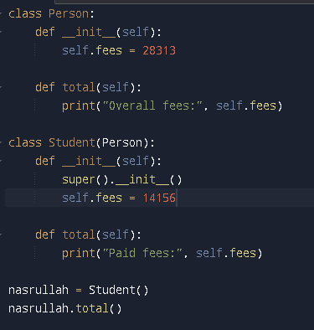
Output:-

b) Overriding in methods
Input:
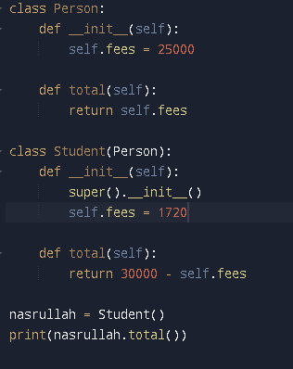
Output:
2. Polymorphism
• String
Input:
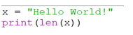
Output:

• Dictionary
Input:
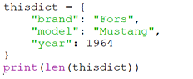
Output:

Input:
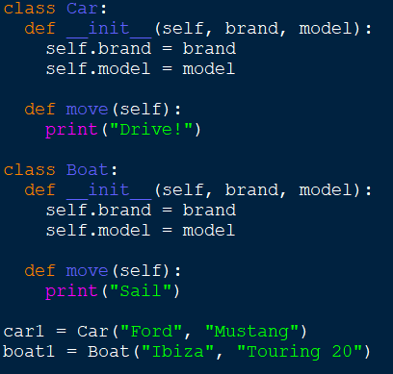
Output:

3. Operator Overloading
Input:
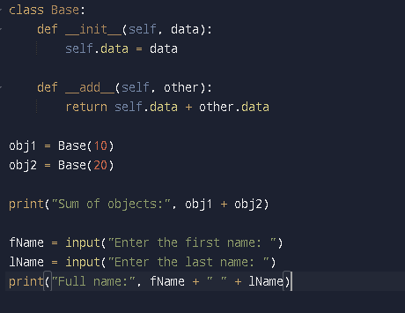

Output:


